Annual CIPAC/FAO/WHO Report Form
on the Quality Control of Pesticides

Country/Name and Address of the Institution (contact person):

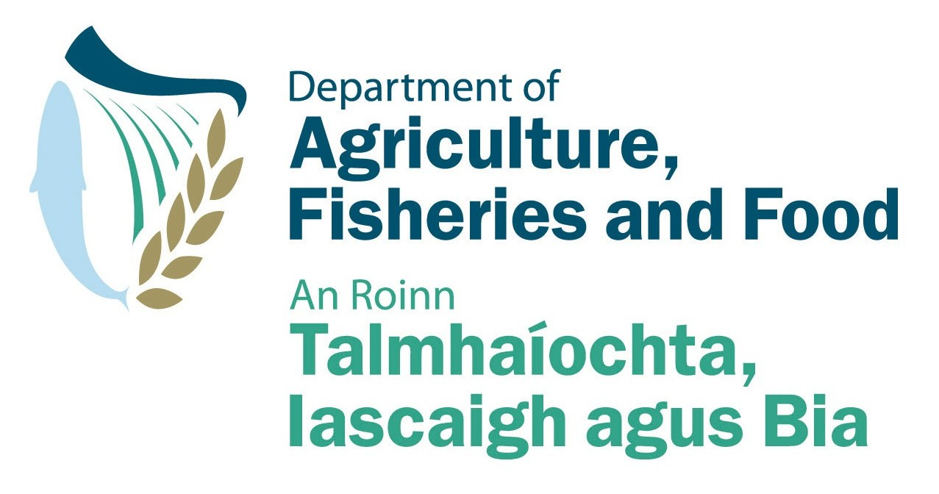
Ireland
Pesticide Control Laboratory
Backweston Laboratory Complex
Young’s Cross,
Backweston,
Celbridge
Co. Kildare. Ph: +353 1 6157603
Ireland Fax: +353 1 6157574

Contact: Dr. Jim Garvey Jim.Garvey@agriculture.gov.ie
1 - Essential Information

Reporting period/year: | Number of samples analyzed (1) | Number of non-compliance (2) | Uses (3)  (optional)
Jan-Dec 2007 | 149 | 19 | Agricultural use: 102
Jan-Dec 2007 | 149 | 19 | Public Health use: 0
Jan-Dec 2007 | 149 | 19 | Home and Garden use: 47
Jan-Dec 2007 | 149 | 19 | Other uses (please specify): 0

(1) Any sample, including those of active inspection and registration control samples.

(2) Non-compliance with FAO/WHO or national pesticide specifications.

The reason of non-compliance: a: All non-compliances were related to the concentration of the active substance. In all but two cases the active substance concentration was higher than the specification with the FAO tolerance taken into account. In the remaining two cases the active substance was lower than the specification with the FAO tolerance taken into account.

(3) If possible, please indicate the use/destination of the pesticide analyzed If the pesticide has various uses, it should be included only in one category and should be explained under item 2 (comments).

2 - Any comments and/or background information

3. CIPAC Activities
The laboratory has taken part in 6 collaborative studies since the last CIPAC meeting. These were

673.Boscalid
511. Cyprodinil
35 .Fenitrothion
526.210 Haloxyfop-P-methyl
612. Indoxacarb
651.229 Mefenpyr diethyl

